Experiment log

p.2 order

p.4 confident

p.5 distinguished mainly from density/pattern， need to learn elements as well

p.6 C/N   混淆

p.7 front speaker 感觉难听清o

p.8 速度在可以比较时更好判断

p.10 N/O harder for localization, C/N 分不清楚 in pretest

p.12 混淆c/n 没有参照, 后方声音会习惯性最后反应

p.13 practice 判定很好，但是需要稍长时间反应，8s 》4s

p.14 mainly from pitch // (music backgrounds) (pretest-Q16) 🡺 back

p.15 too loud 🡺 lower sound，C, H 如果单独就会混淆，比较就更好区分

p.16 density / speed

p.17

p.18 feel frustrated in the pretest, was not confident about his hearing memory at all

p.20 c in 3H （density）

p 22, speed

p23 metaphor: bassdrum, bell sound

p.24 pitch判断需要参照，不然就会shift?

p.25 鼠标挪动速度太慢 / speed

p.26 h c n o / 1 2 3 4 指代

p27 instict feeling

27 participants, 17 males, 10 females. Age range is between 20-30 (1 is 39 and 1 is 46).

Here are some figures generated from the original results in R.

1. Correct rate for four directions (pre/post)

Boxplot, outliers are displayed but not excluded for calculation (<https://ggplot2.tidyverse.org/reference/geom_boxplot.html>)

Data beyond the end of the whiskers are called outlying points and are plotted individually (1.5*IQR from the hinge, IQR is the inter-quartile range, or distance between the first and third quartiles)

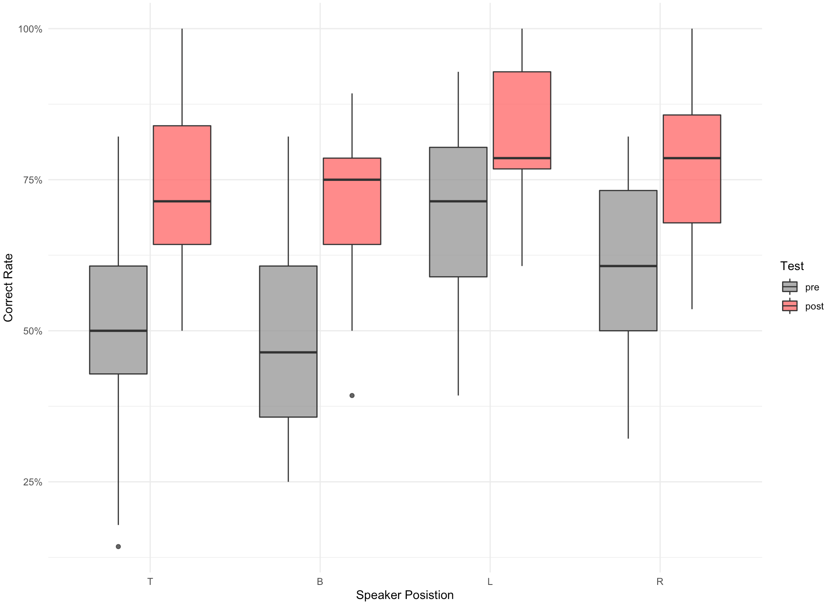

graph_position_correct_rate <- ggplot(mysound.position, aes(x = variable, y = (value/28), fill = Type))+

geom_boxplot(alpha = 0.8)+

scale_x_discrete(name = "Speaker Posistion")+

scale_y_continuous(labels = function(x) paste0(x*100,'%'))+

ylim(0,1)+

theme_minimal()+

scale_fill_manual(breaks = c("pre", "post"),

values=c("#999999", "#FF6A6A"))+

labs(fill ="Test", y = "Correct Rate")

1. Correct rate for four elements (pre/post)

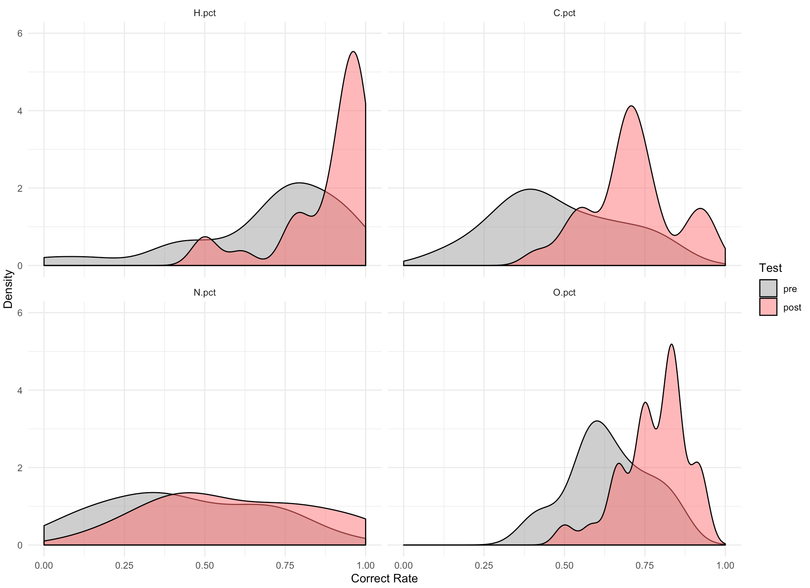

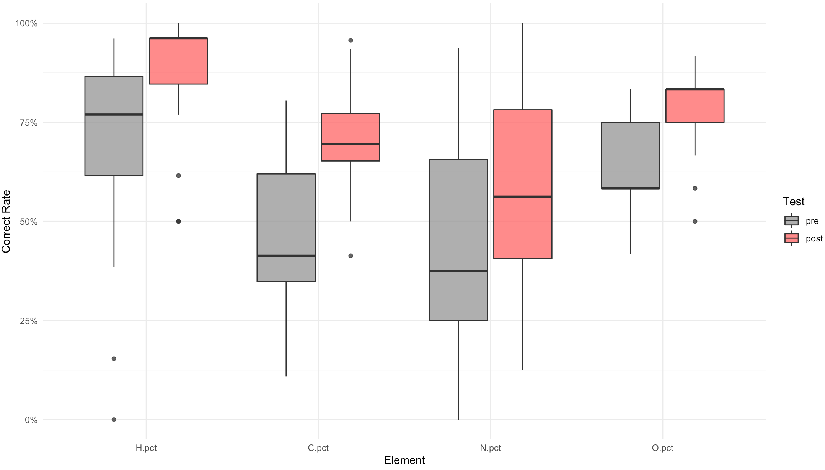

1. Final score (pre/post)

Density plot visualizes the distribution of data over a continuous interval, which uses kernel smoothing to lot values. It estimates the probability density function of a random value.

..density.. 显示密度distribution分布

..scale.. 显示出现频率分布

..count.. 显示具体数量

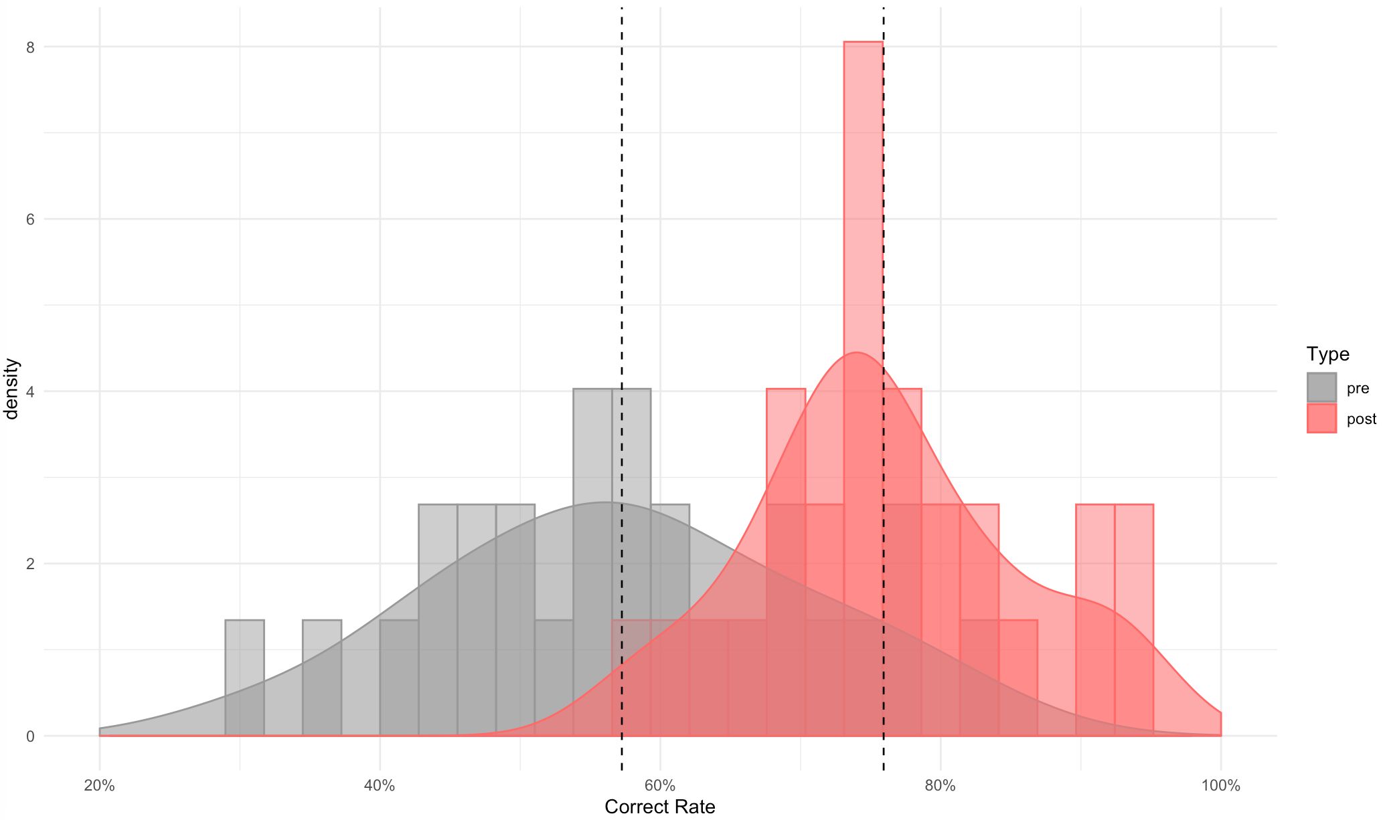

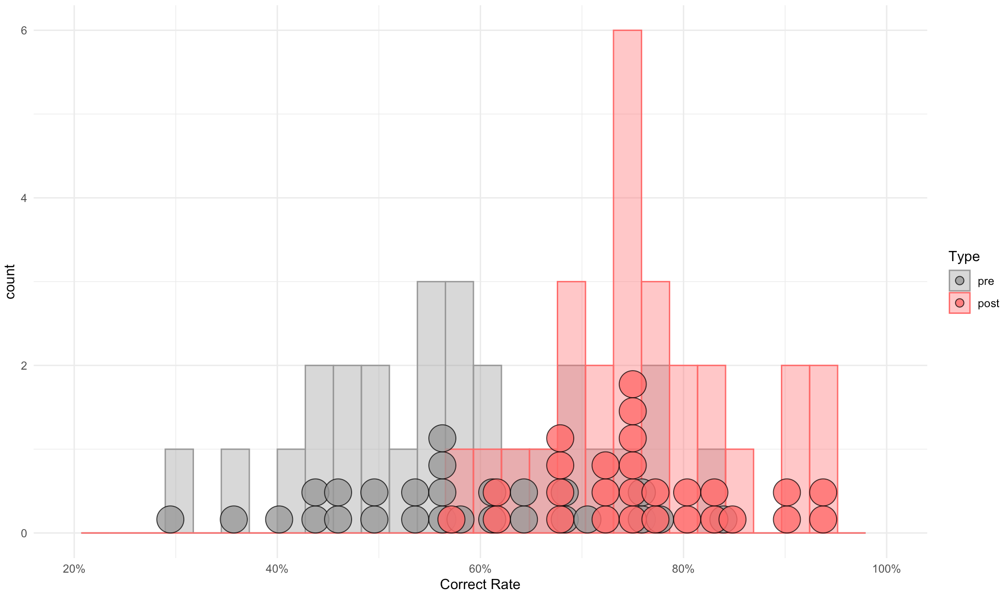

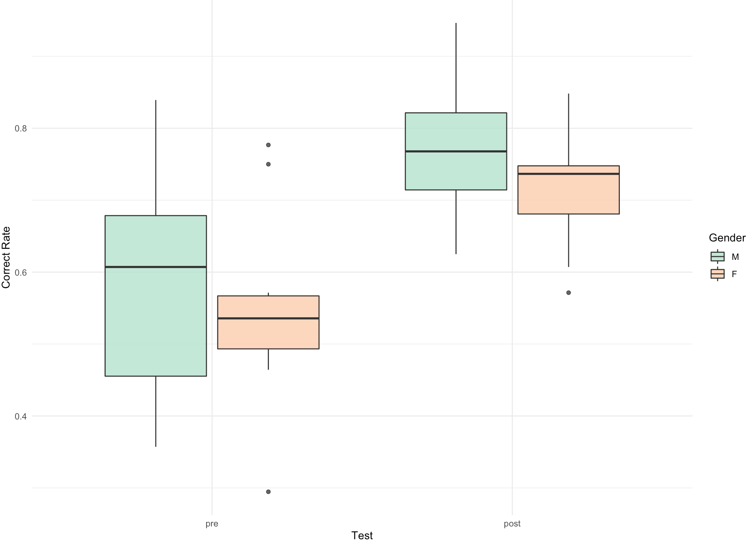

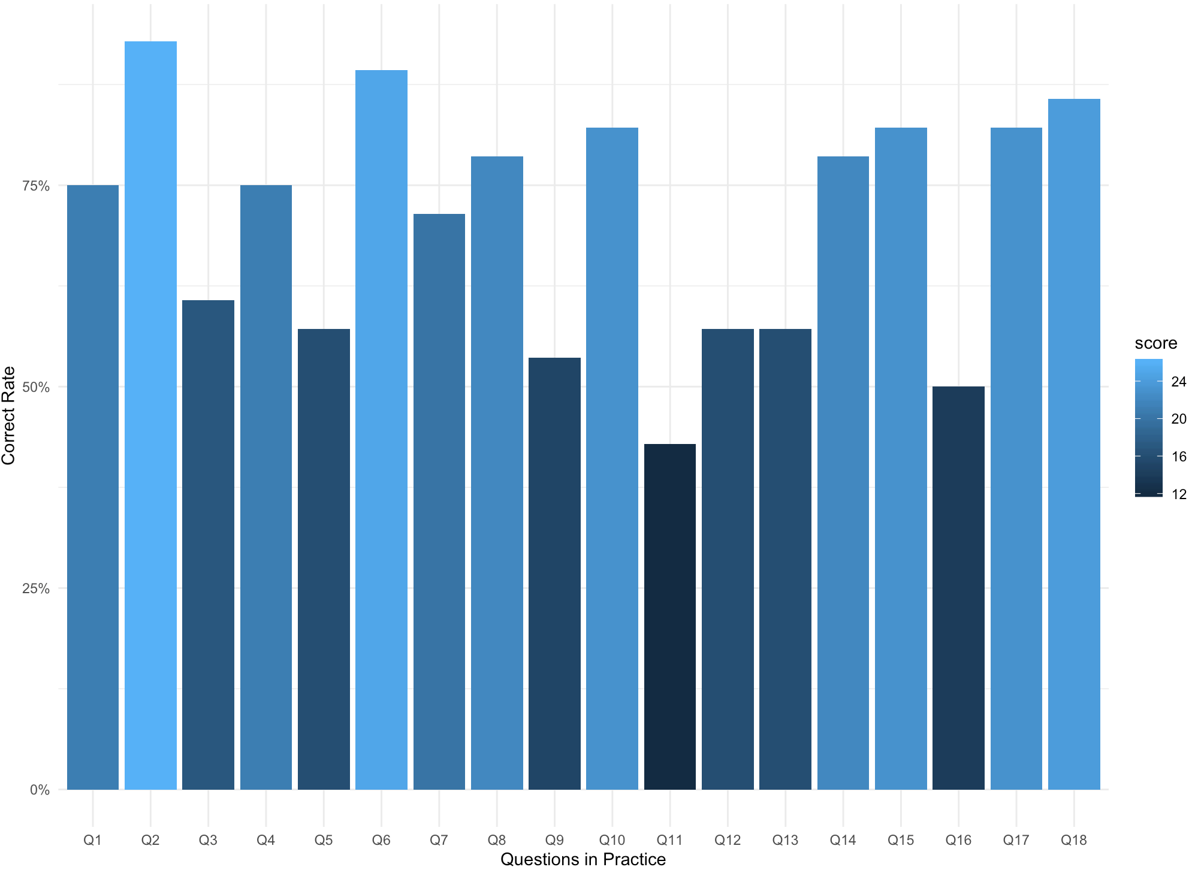

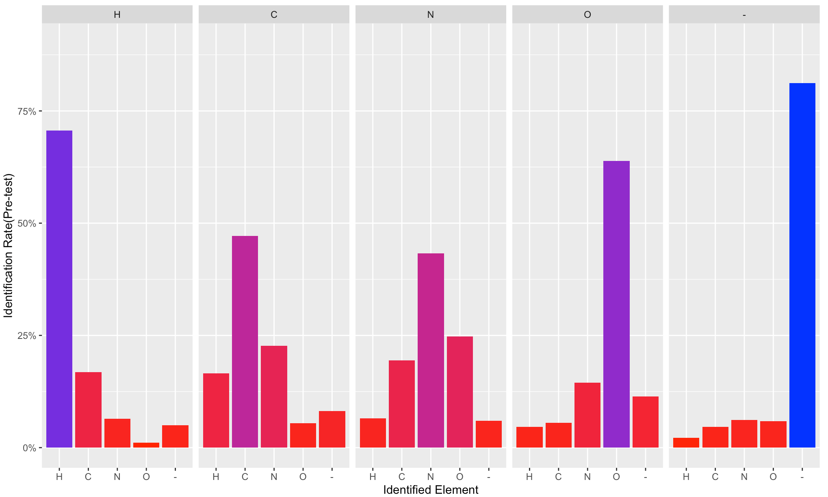

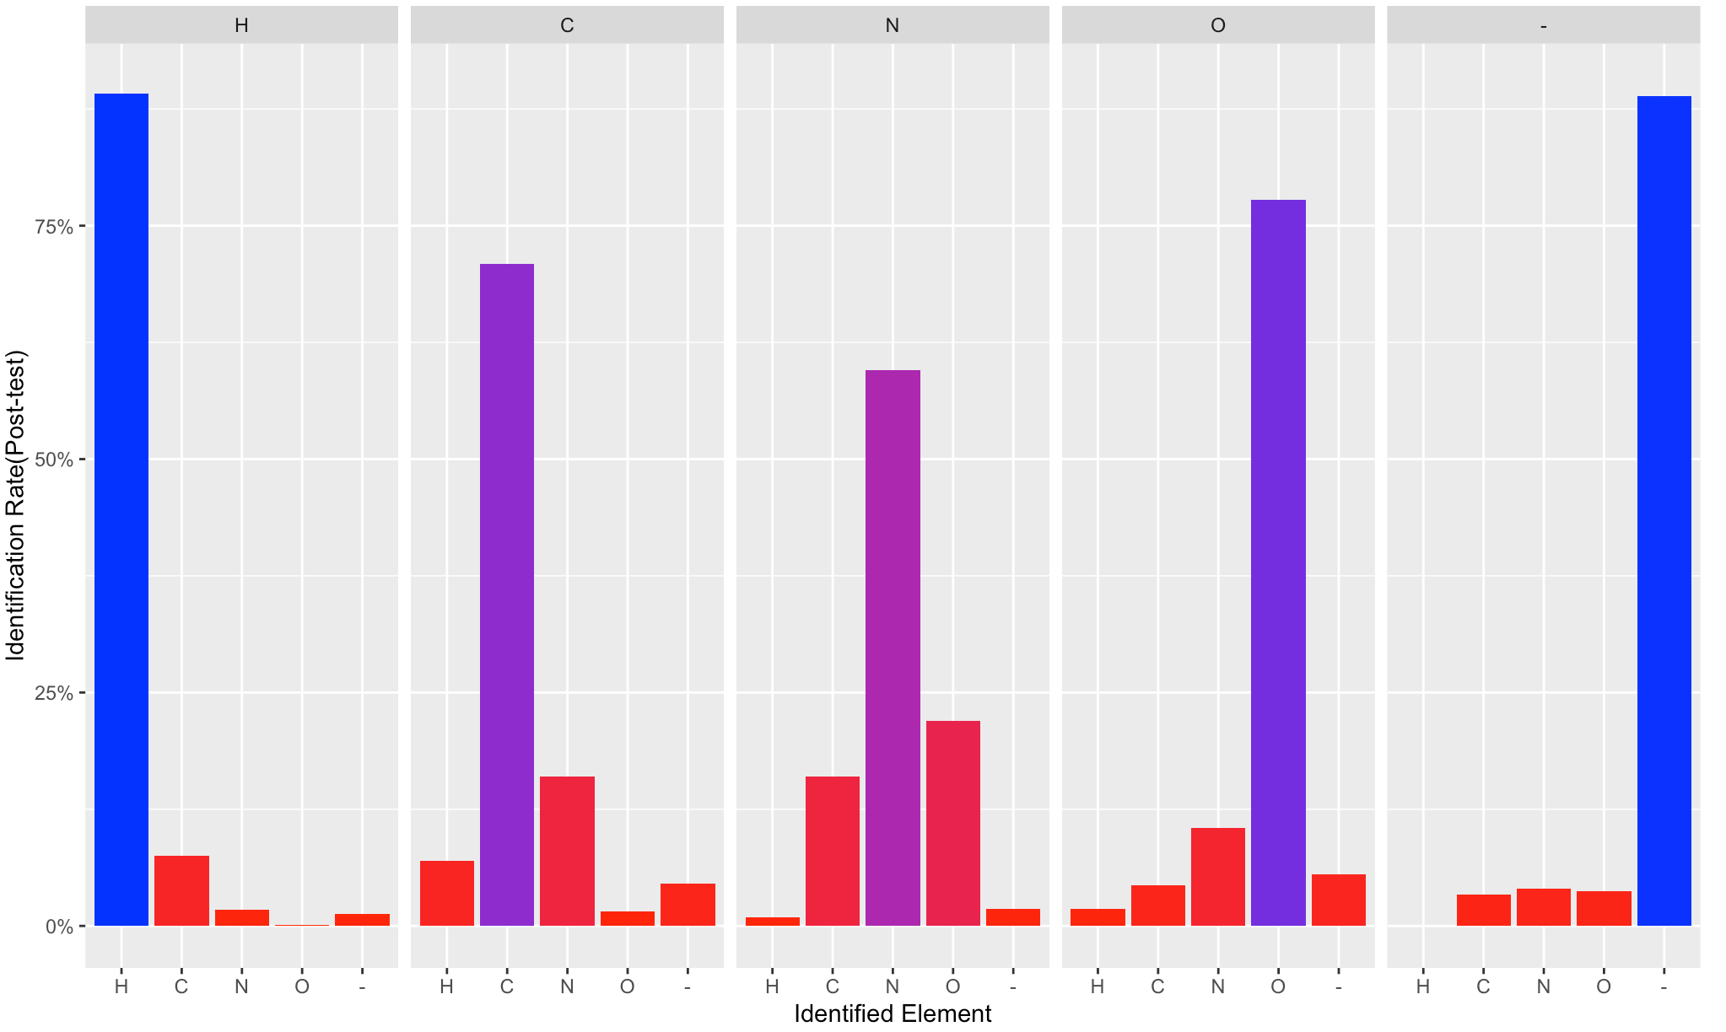

4000/8000 (14 combinations)

pre

post

mytime_post <- mytestquestion_post %>% select(c('question','time','avg'))

mytime_post$question <- ifelse(mytime_post$question %%2 == 0 , mytime_post$question/2, (mytime_post$question+1)/2)

mytime_post%>%

ggplot(., aes(x = question, y = avg, color = as.factor(time), fill = as.factor(time)))+

geom_point()+

geom_line()+

scale_y_continuous(limits = c(0.5,1),labels = function(x) paste0(x*100,'%'))+

xlim(0,15)+

scale_fill_brewer(palette = "Set2") +

scale_color_brewer(palette = "Set2")

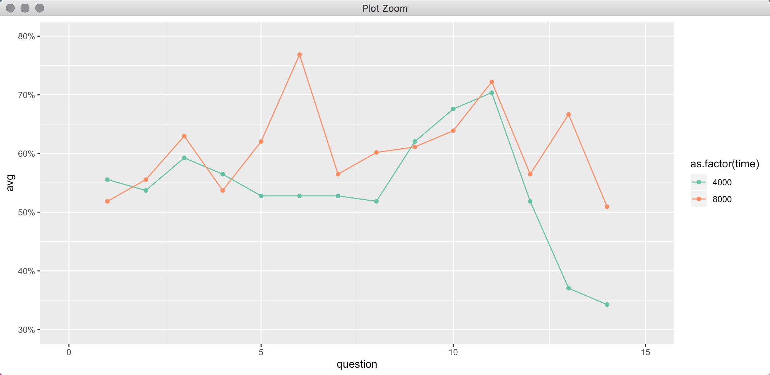

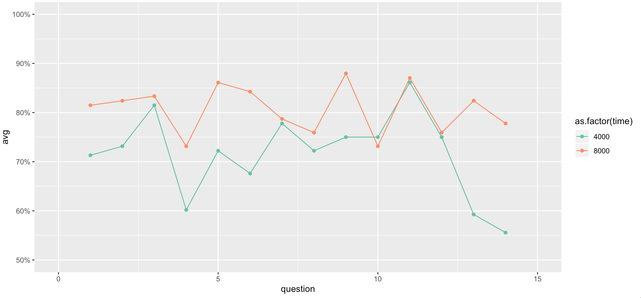

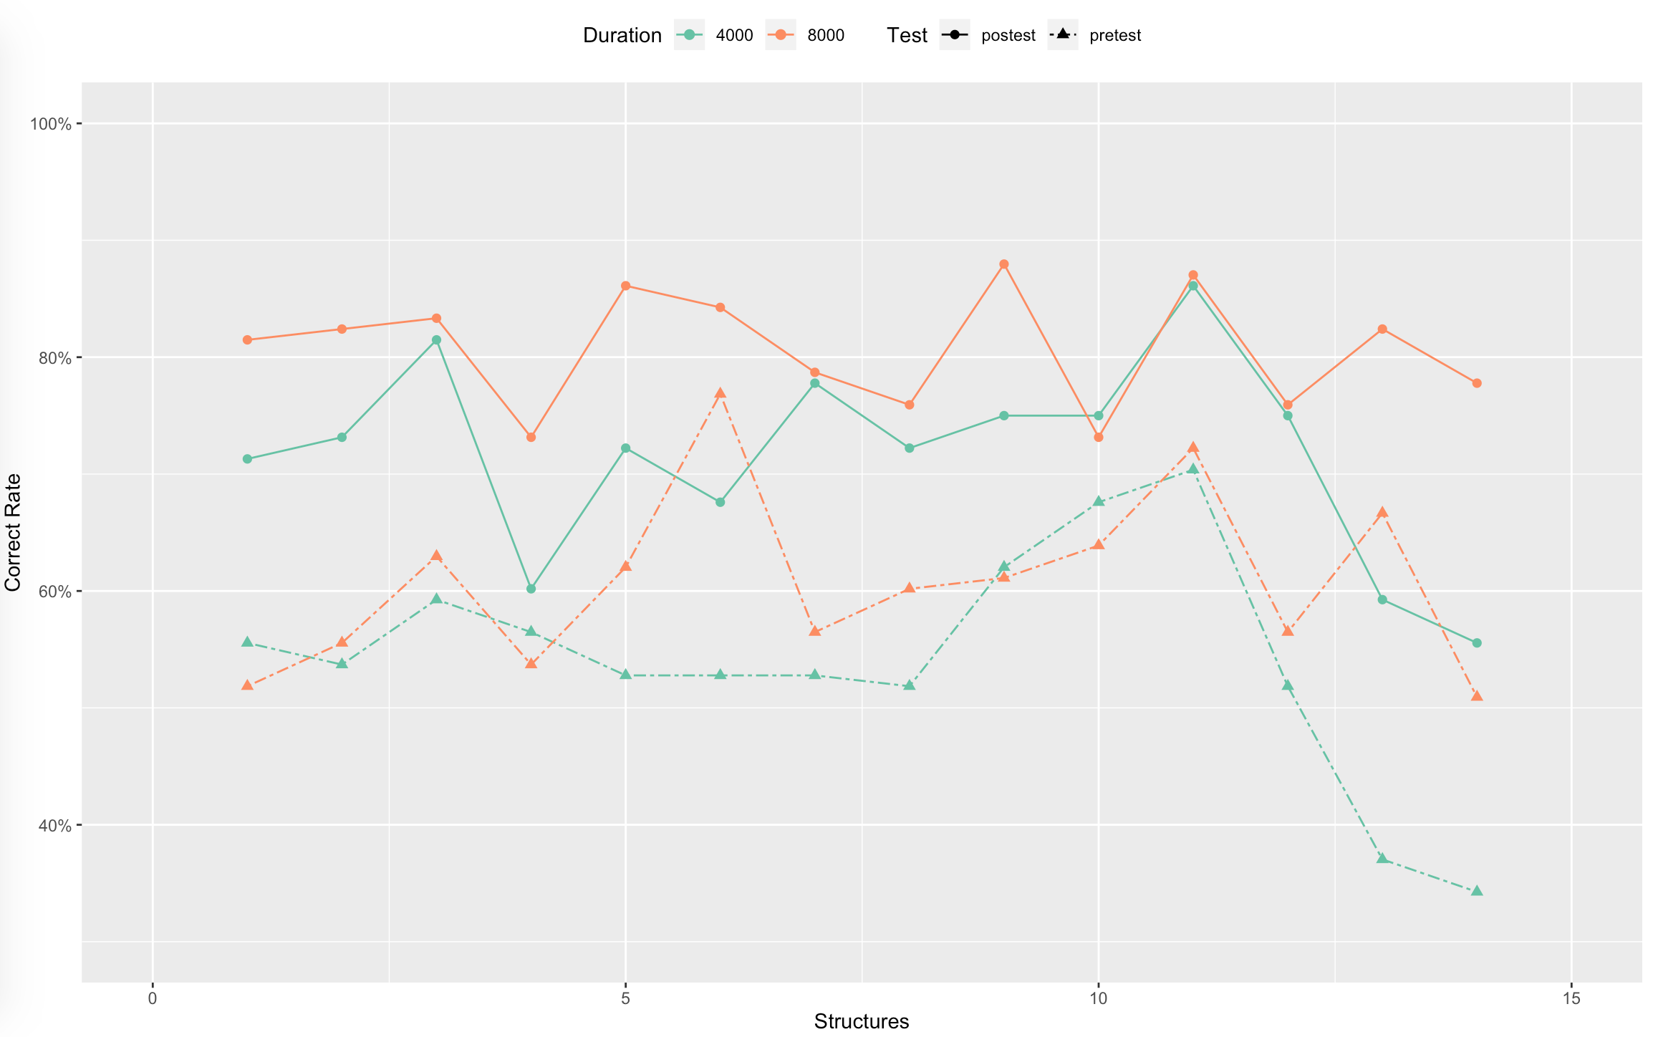

"CCCC4", "CCCC8", "-CNC4", "-CNC8", "-COC4", "-COC8", "-NNN4", "-NNN8", "-NOC4", "-NOC8", "C-OO4", "C-OO8", "CCCH4", "CCCH8", "CCOH4", "CCOH8", "CHCH4", "CHCH8", "H-NC4", "H-NC8", "HHHC4", "HHHC8", "HNHC4", "HNHC8", "HOHC4", "HOHC8", "NCCH4", "NCCH8"

LBRT顺序

三个声音 （12）3，4，5，6，7，8，9，10，11，12，19，20

四个声音（16）